**Burrp!**

www.burrp.com

**Insta Offers Module**

Product Note & Technical Architecture

|  |  |  |  |
| --- | --- | --- | --- |
| **#** | **Author** | **Note** | **Date** |
| 1 | Vinay Kant Sahu | Initial Product Notes | Feb 19, 2016 |
|  |  |  |  |
|  |  |  |  |
|  |  |  |  |
|  |  |  |  |
|  |  |  |  |
|  |  |  |  |
|  |  |  |  |

INDEX

1. INTRODUCTION 3

2. PROPOSED SYSTEM 3

2.1 BURRP BUSINESS PORTAL 3

2.2 BURRP APPLICATION 5

2.3 JIO PLATFORM 5

3. TECHNICAL ARCHITACTURE 5

4. TIME LINE 6

**Introduction**

Most of the foodie consumer loves offers; as well restaurant owners also want to serve offers to those who are interested and can avail those offers within a time period. The time bound offers are actually helpful to merchants when they are not having much traffic at specific time and to avail an offer within a time bound limit; it is required to inform only those who are nearby/within a given range from the restaurant or can reach before offer closed.

To facilitate creation of Instant Offers to be delivered in almost real time to end subscribers who are within proximity of intended location of offer, Burrp is planning to use Jio InstaOffers Platform. Jio InstaOffers platform provides a set of APIs to create Offers and searching users in given range. By integration JIO APIs all the Burrp Business users will be able to create instant time bound offers for Burrp users using Burrp Business Portal (<http://biz.burrp.com>), all Burrp users will be added as subscriber to Jio platform.

Burrp User will be able to get offer information via SMS, Push Notification and Email; depends on the availability of the user information.

**Proposed System**

As described above, there are three major stakeholders; Burrp Business Portal, Burrp Application (WEB, WAP and mobile Apps) and Jio API Platform.

1. **Burrp Business Portal**:

All the registered Business Owners at Burrp will be able to avail option to create InstOffers, for this they need to be logged-in and register them as InstaOffer Merchant followed by Admin approval (Price & package discussion is the part of Business team).

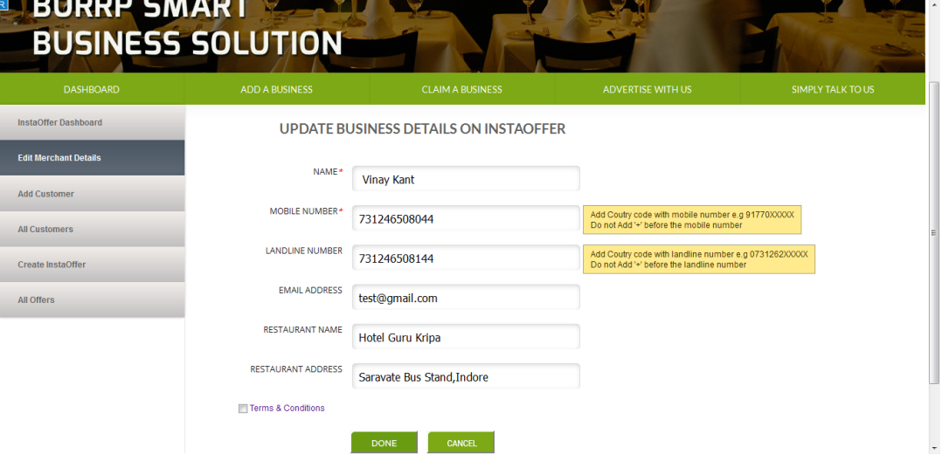

Merchant will be able to get report in terms of head counts for how many users received offer, how many opened the offers etc.

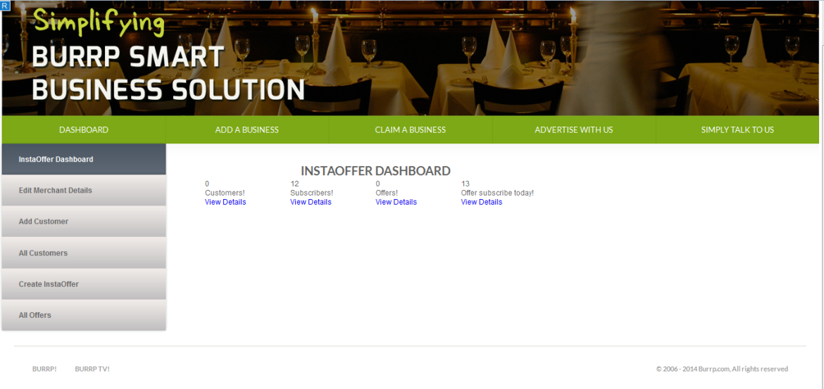

Once Business Owner is approved merchant, he/she will be able to create an offer and check how many Burrp Users + Jio InstaOffer subscribers within the given range from his/her establishment.

Merchant will be able to set time period to avail this offer as well select the target subscribers.

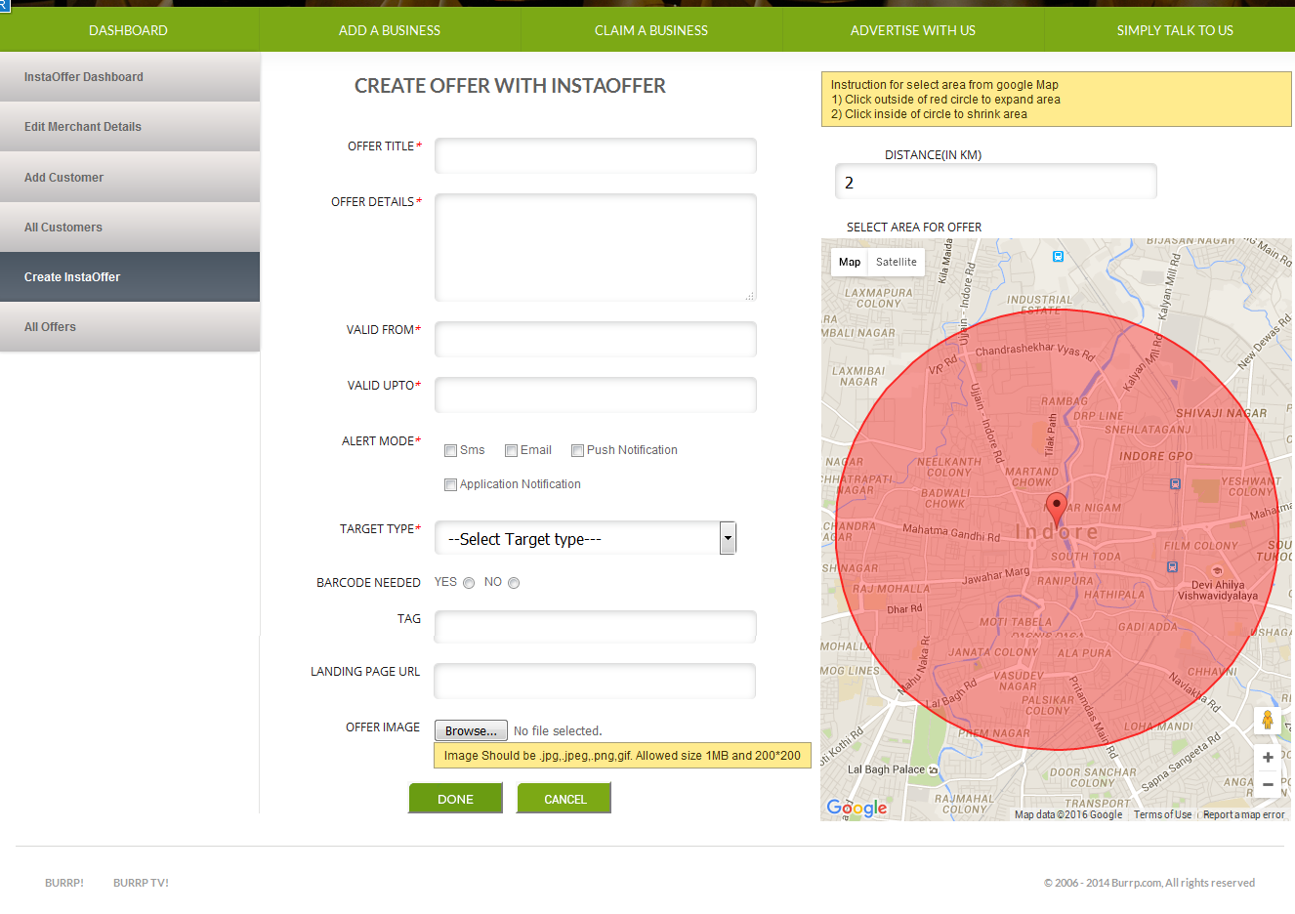

1. **Burrp Application**

All the Burrp users will be listed as subscribers to Jio InstaOffer platform and in Login process (Using Password/FB/Twitter) APIs we need to make sure users will be added as JIo InstaOffer subscriber. In mobile apps needs to make changes to receive Push Notifications and location share (If available) with each API call

Once user location is in the range of pushed offer user will receive SMS/Email/PushNotification based on information available.

1. **Jio API Platform**

Jio InstaOffer Plateform is the main engine for this module, to register merchant, adding user as subscriber, creating offers as well sending offers of other JIO merchants to Burrp users we are going to use APIs provided by JIO.

**Technical Architecture**

**Data Flow**

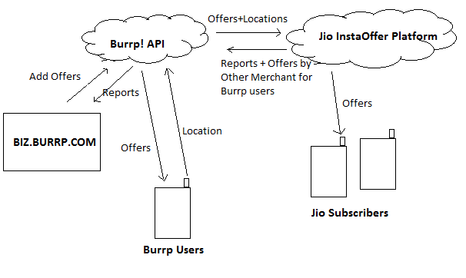

**Time Line**

1. Push Notification On Burrp Apps 12th Feb 2016
2. Offers creation on Biz Portal 24th Feb 2016
3. API Integration with JIO 10th Mar 2016
4. Display Offers On Burrp App 10th Mar 2016
5. UAT Release 14th Mar 2016
6. Production Release 21st Mar 2016