

SECO Developer Guide

# Document Version History

|  |  |  |  |
| --- | --- | --- | --- |
| *Version* | *Date* | *Description of Change* | *Author/Owner* |
| 1.0 | 22-March-2013 | This document contains the steps for developers registration and subscription to APIs | Garima Singh |
| 1.1 | 23-Dec-2013 | Updated portal links for different environments and steps to import certificate for Android/iOS and application clients |
|  |  |  |
| 1.2 | 22-Sept-2015 | Updated screenshots reflecting new developer portal v3.0 and added steps to how to access API | Omkar Acharya |
| 1.3 | 01-Oct-2015 | Updated the Screenshots (Bordering the Screenshots) and added steps to how to send invitation to Developers. |
|  |  |  |
|  |  |  |  |
|  |  |  |
|  |  |  |

# Registering as a developer on API Portal

SECO Admin- **RJIL.APIPlatform@ril.com**

**Portal links for different environments**

DEV API Portal: - <https://devportal.ril.com/>

ST Portal :- <https://stportal.ril.com/>

SIT Portal :- <https://sitportal.ril.com/>

E2E Portal:- <https://iotportal.ril.com> (For E2E lab)

<https://10.135.4.128> (Outside E2E lab)

PreProd Portal :- <https://preprodportal.ril.com/>

Replica Portal:- https://developers.jiolabs.com

Prod Portal: - <https://developers.ril.com>/

1. Go to API portal home page and register yourself as a developer by clicking on **Signup**.

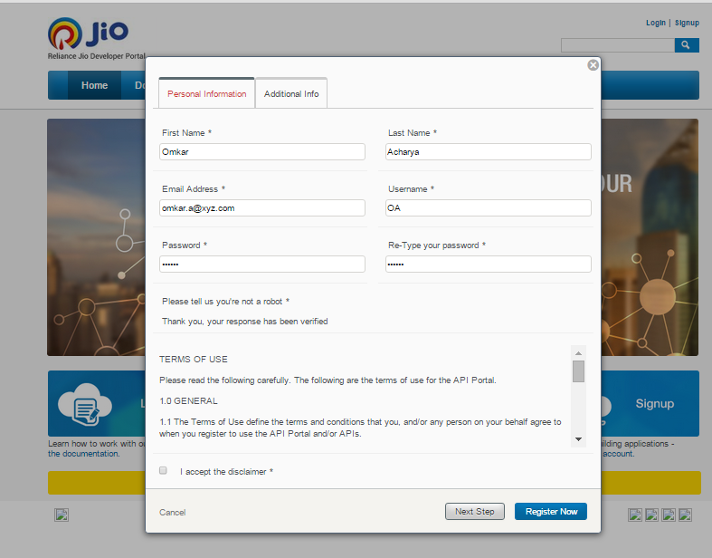

Click Next.

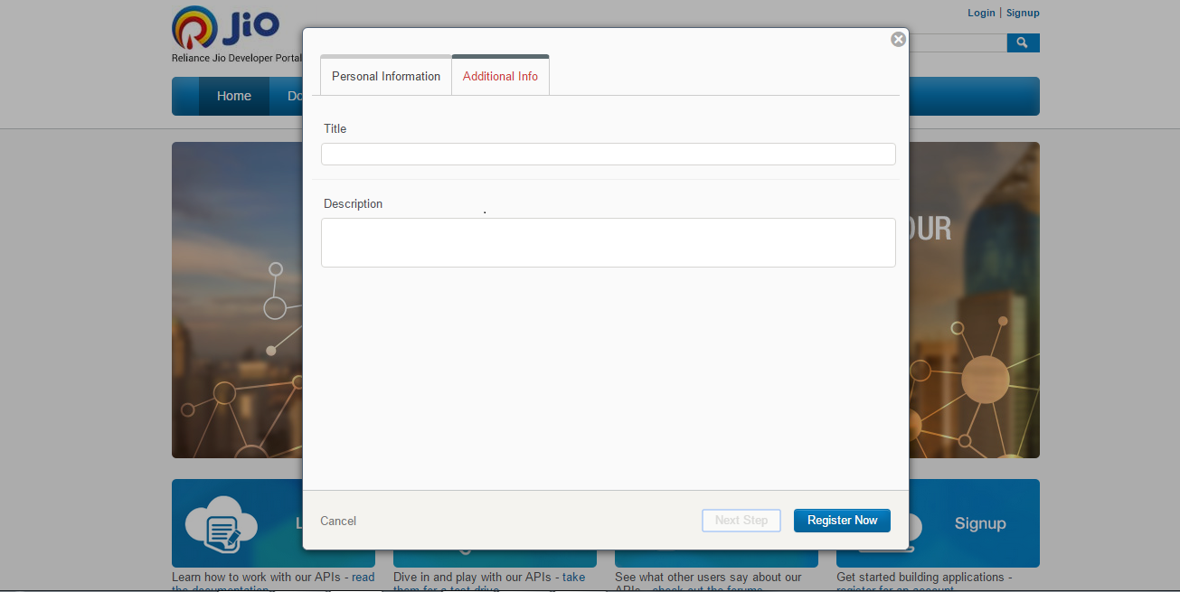

Provide additional details and click Register Now when done. The Title in the additional information section signifies the name of the Organization (for eg: Name of the Company in which Developer is working) and Description section signifies the additional data about the organization.

1. Registration request will be sent to SECO admin for approval.
2. Once registered, drop a mail to SECO admin to approve registration and application.
3. Once approved, your id is activated. You can log in to portal.
4. The person who registers is the organization admin. He can send invitations to his developers.

# Steps to Send invitation to Developers

The Organisation admin after registering himself/herself can send invitations to the developers of his choice as shown in the figure below.

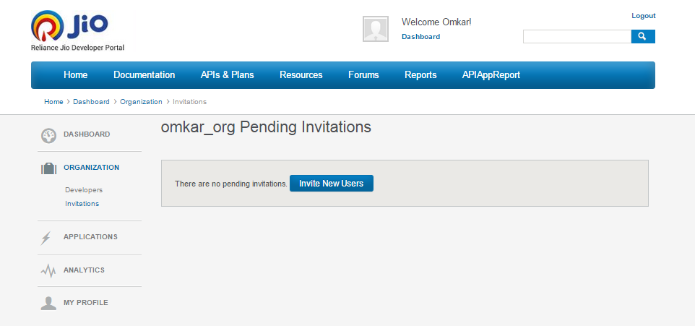

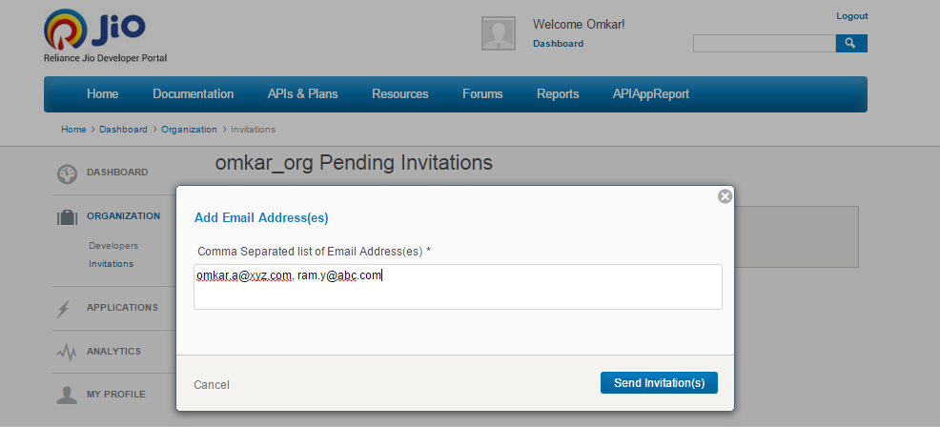

By Clicking on the Invite New Users button, you can invite developers by sending the invitation by email. The developer(s) after receiving the email will also have to register on the portal. But they will not be required to give details for the organization during the registration. Developer(s) then can create application(s) in the admin’s organization who has sent them the invitation.

# Steps to Create an Application

After successful registration on the required portal, an organization gets created on the portal with your registered credentials. Now to access the API key, you need to add an application in your organization.

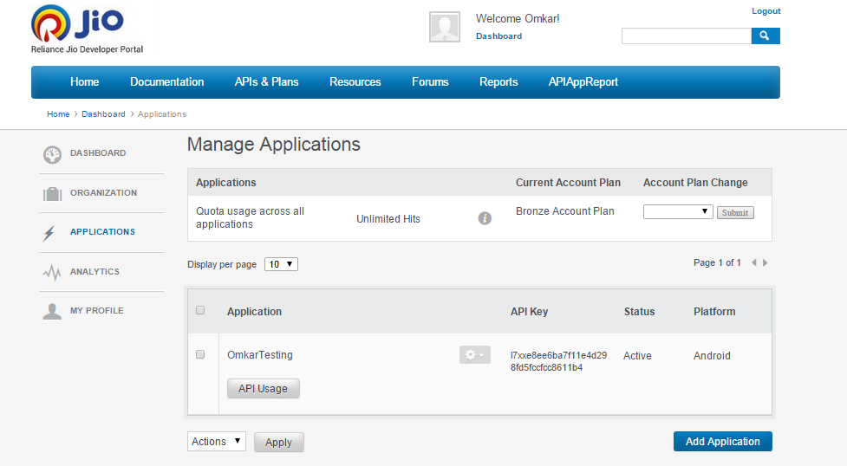

1. In your organization, click on the Add Application button to add an application as shown in the above figure.
2. A window pop-ups where you need to give the information about the application (for eg: application name). The following figures describe the steps.

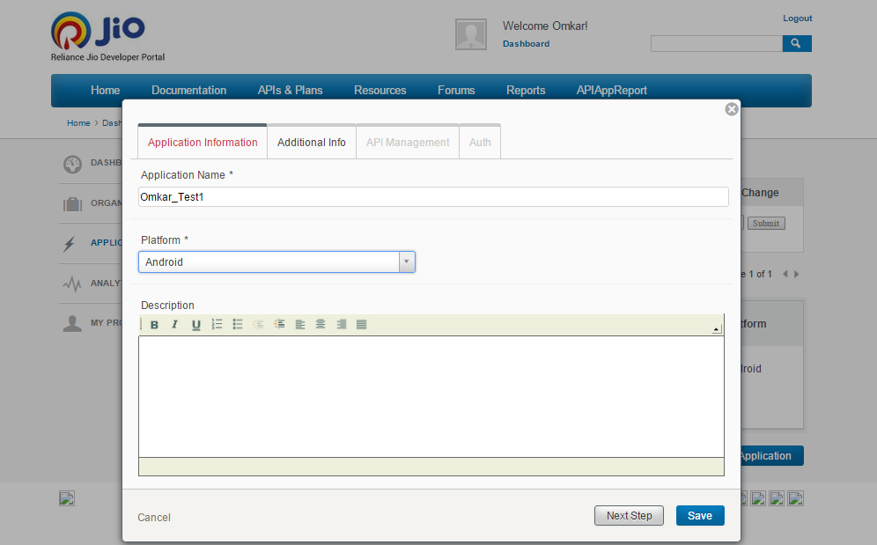

After providing the Name and Platform of Application, click on the Next button.

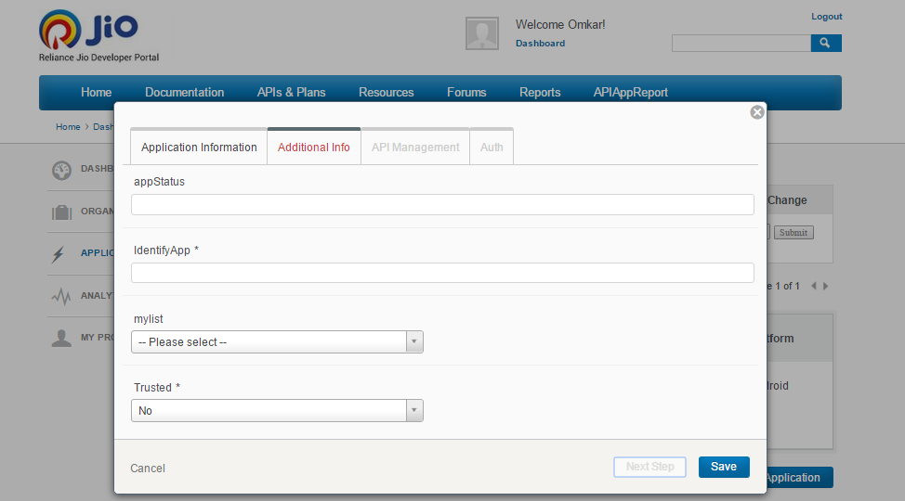

After providing additional information about the application, click on Next button.

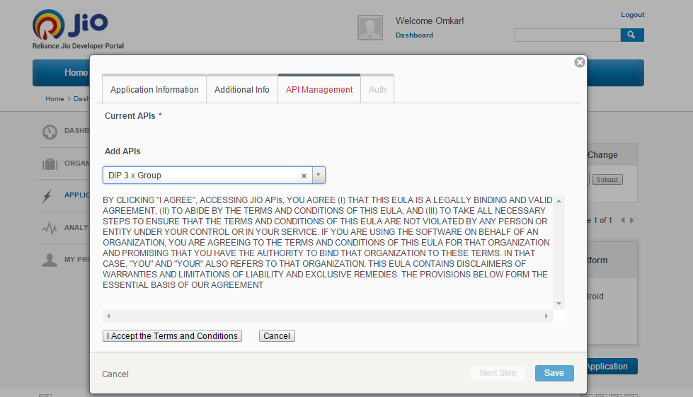

In the API Management section, you need to select the desired API from the Add API’s select box and Accept the terms and Conditions and save the selected API.

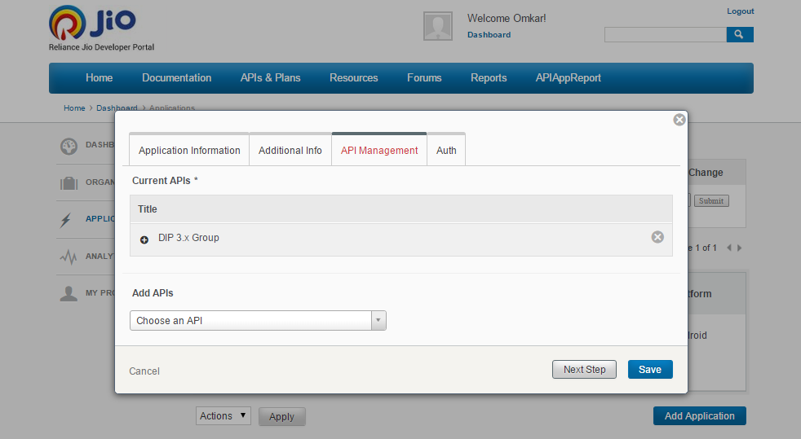

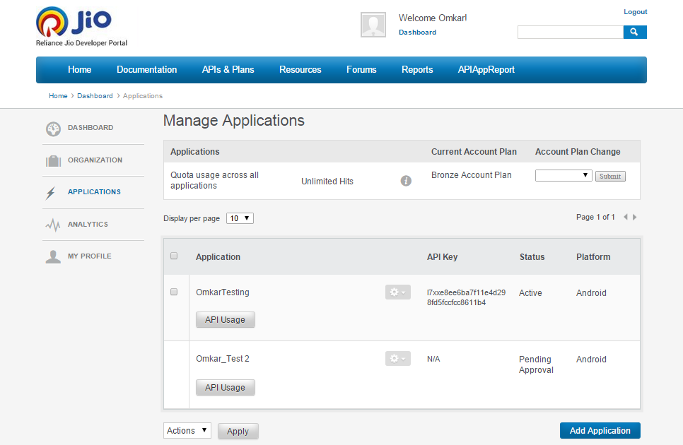

After the created application is saved, it appears within your organization with Approval Pending as shown in the above figure. Contact the SECO Admin for the approval. After approval you can use the API key which appears in front of the application.

# Steps to access a newly published API/add more APIs

New APIs will not be accessible to applications by default. Below steps are required in order to make these APIs available to applications.

1. Go through the updated API guide of the R4G enabler (e.g. DIP)
2. Login to the API Portal of SECO
3. Select your application > edit it to add new APIs

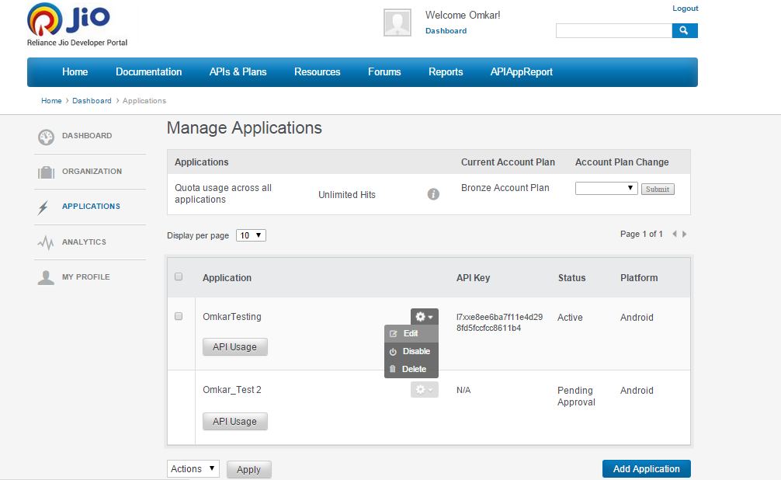

1. Add your desired API(s) to your application.

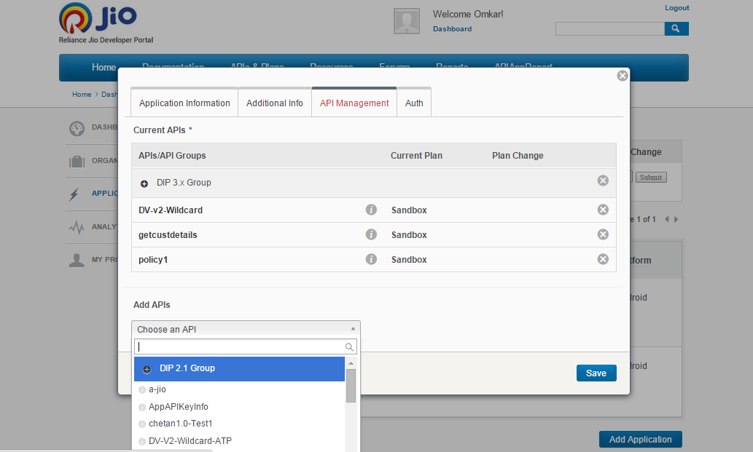

5. If you do not find desired API (published in the API guide) in SECO "Add APIs" list, then contact SECO team for clarification.

# Step to access the API

After creating an application, use the API key assigned to the application to access the SECO API.

1. Use the header for using the API key as **X-API-Key**.
2. The value of the header is the value of the API-key.

Example: **X-API-Key : l7xxd7xxxxxxxxxxxxxxxxxxxxx**

# Steps to export certificate from browser

**SSG Links for different environments**

DEV: - https://api-dev.ril.com:8443/

ST:- https://api-st.ril.com:8443/

DEVINT/SIT: - https://api-sit.ril.com:8443/

E2E:- https://api-iot.rii.com:8443/

PREPROD/UAT: - <https://api-preprod.ril.com/>

REPLICA :- https://api.jiolabs.com/

PROD :- <https://api.ril.com/>

1. Go to respective environments SSG link and download the certificate from browser.

E.g. in Chrome browser, click on the lock sign in the address bar > Go to Connection Tab > Click on *Certificate Information* link

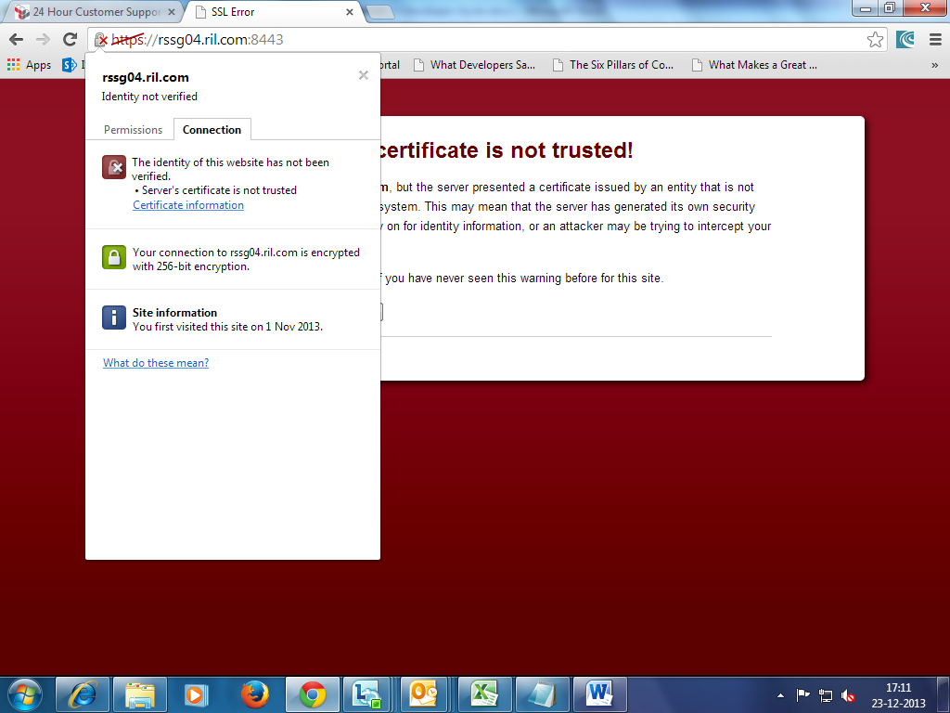

Next Click on ***Details*** Tab > ***Copy to File >*** Accept all default and save the certificate.

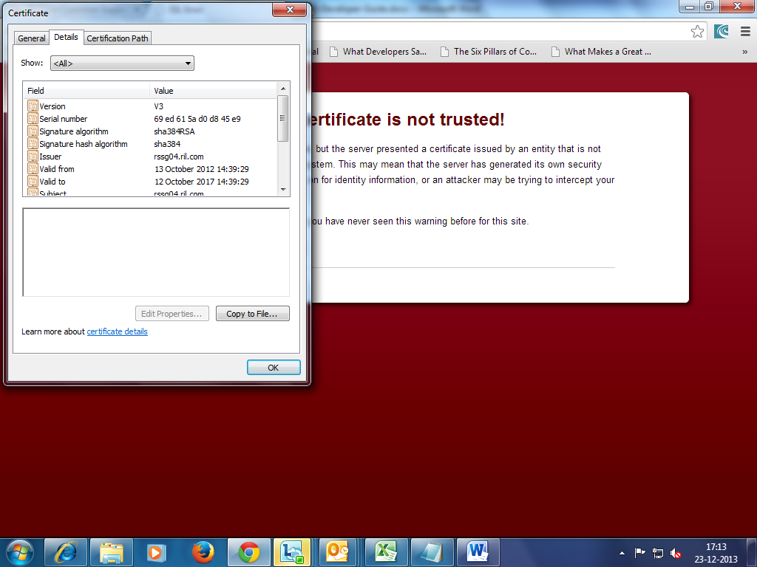

# Steps to import certificate and key

## Installing the SSL Certificate and Key on the iOS Client

You should install the SSL distribution certificate and private cryptographic key you obtained earlier on the server computer on which the provider code runs and from which it connects with the development or production versions of APNs. To do so, complete the following steps:

1. Open Keychain Access utility and click the My Certificates category in the left pane.
2. Find the certificate you want to install and disclose its contents.

You’ll see both a certificate and a private key.

1. Select both the certificate and key, choose File > Export Items, and export them as a Personal Information Exchange (.p12) file.
2. Servers implemented in languages such as Ruby and Perl often are better able to deal with certificates in the Personal Information Exchange format. To convert the certificate to this format, complete the following steps:
   1. In KeyChain Access, select the certificate and choose File > Export Items. Select the Personal Information Exchange (.p12) option, select a save location, and click Save.
   2. Launch the Terminal application and enter the following command after the prompt:

openssl pkcs12 -in CertificateName.p12 -out CertificateName.pem -nodes

1. Copy the .pem certificate to the new computer and install it in the appropriate place.

Reference - <https://developer.apple.com/library/ios/documentation/NetworkingInternet/Conceptual/RemoteNotificationsPG/Chapters/ProvisioningDevelopment.html>

## Installing the SSL Certificate and Key on Android Client

1. Once you have the .keystore file and passphrase file, embed .keystore file in asset folder of application
2. Write java code to read .keystore file using the passphrase. Sample java code is attached - 
3. Create SSL connection using certificate within the .keystore.

## Installing the SSL Certificate and Key on Java/Other Application Client

1. Once you have the .keystore file and passphrase file, write code to read .keystore file by providing .keystore file path and using the passphrase. Sample java code is attached -
2. Create SSL connection using certificate within the .keystore.